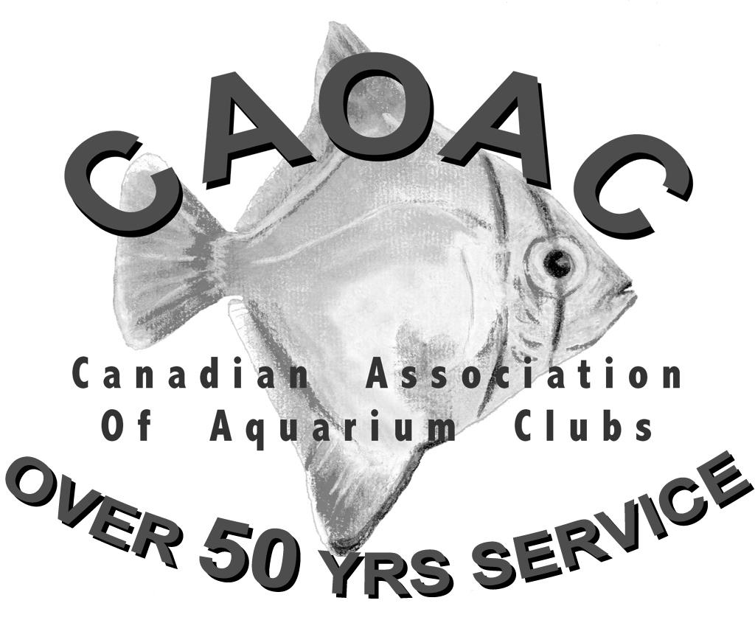
Application for
Breeders Awards

Check category being applied for:
 | General |  | Livebearers
 | Killifish |  | Catfish
 | Characins |  | Cichlids
 | African Rift Lake Cichlids
Check award being applied for:
Basic
Intermediate
Advanced
Senior

Part A - Personal Information
Name Club Affiliation

Address

Number of Aquariums
Telephone Years in Hobby

C.A.O.A.C. Awards held (if any):

Please print name as it is to appear on certificate:

Are you planning to attend the Awards Presentation at the C.A.O.A.C. Convention?
Yes No

Part B - Sponsoring Executive
Comments:

Signature: Date:
Position : Page 1 of

Remember: Applications should be complete to facilitate the work of the Awards Committee; attach the Breeders
Award Spawning Resumé to support this application.
CANADIAN ASSOCIATION OF AQUARIUM CLUBS
SECTION C - BREEDERS AWARD SPAWNING RESUMÉ
# | Species Spawned | *List Family Class Here  Catfish, Cichlid, Killie etc. | Total  Number of  spawnings | Number  of fish  raised

Name of Applicant:_________________________________________ Date:___________________
The person requesting the Award
Signature of Applicant:_______________________________ cannot sign as authorization !
CLUB
Verification signature:_______________________________ POSITION: _____________________

Please make sure that the form is legible and complete!

*Note: - Please indicate the family class as it relates to the award being sought.
i.e. - intermediate Merit Award requires seventeen species. 3 Cichlids; 4 Livebearers; 2 Anabantids etc.
Please indicate this in this column.
Page ___ of ___ .

