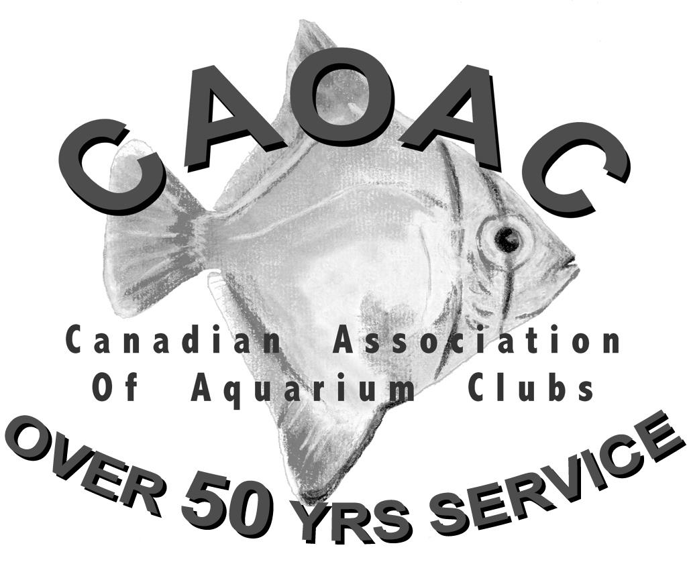
Application for
Horticulturalist Awards

Check award being applied for:
 | Aquatic Horticulturalist |  | Expert |  | Master
 | Advanced |  |  |  | Grand Master

Part A - Personal Information
Name Club Affiliation

Address

Number of Aquariums
Telephone Years in Hobby

C.A.O.A.C. Awards held (if any):

Please print name as it is to appear on certificate:

Are you planning to attend the Awards Presentation at the C.A.O.A.C. Convention?
Yes No

Part B - Sponsoring Executive
Comments:

Signature: Date:
Position : Page 1 of

Remember: Applications should be complete to facilitate the work of the Awards Committee; attach the Horticulturalist
Award Propagation Résumé to support this application.

CANADIAN ASSOCIATION OF AQUARIUM CLUBS
PART C-HORTICULTURALIST AWARD PROPAGATION RESUMÉ
# | Species Propagated | Vegetative | Flowering | Seeds | Sexual | Points | Class

Name of Applicant:_________________________________________ Date:___________________
The person requesting the Award
Signature of Applicant:_______________________________ cannot sign as authorization !
CLUB
Verification signature:_______________________________ POSITION: _____________________

Please make sure that the form is legible and complete!
Level | Points Req’d | # Species | Class Requirements
Aquatic Horticulturalist | 50 | 4 | B, C, D
Advanced | 120 | 12 | 2 from Cm 2 from D & 1 from E
Expert | 250 | 30 | 2 from D, 2 from E & 1 from F
Master | 500 | 40 | 3 from D, 3 from E, 2 from F & 1 from G
Grand Master | 1000 | 80 | Plus 1 of either a lecture, photo essay or article

